
MCCGJA News Bulletin
June 6, 2025 – Vol. 7

Court Appoints the 2025-26 Marin County Civil Grand Jury
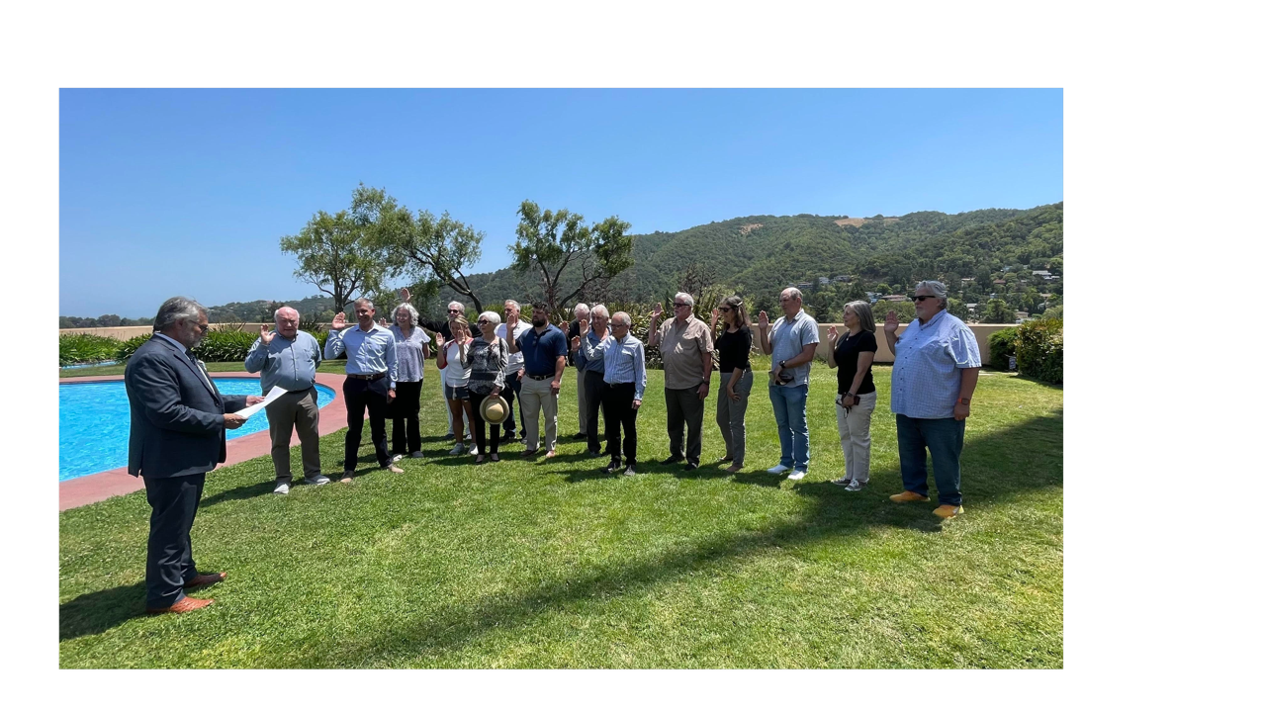
The Hon. Mark Talamantes, Presiding Judge of the Marin County Superior Court, swears in the new 2025-2026 Marin County Civil Grand Jury at the Civic Center on June 5. The 2025-2026 jurors (pictured from left to right) are: Patrick Woods of Novato, Holk Bergmann of Tiburon, Elizabeth Fugate of Greenbrae, Marc Madden of Corte Madera, Elaine Ng of Kentfield, Susan Faresh of Novato, Daniel Martino of Novato, Michael Schubert of San Anselmo, Kevin McGrath of Mill Valley, Thomas Cook of Corte Madera, Charlie Hotz of San Rafael, John May of Mill Valley, Lisa Cooper of San Anselmo, Joseph Mullin of San Anselmo, Jill Lynch of Tiburon, and Dimitri Shikaloff of San Rafael. Others appointed to the new jury but not pictured are: Jake Dear of San Anselmo, Kathleen Schaefer of San Anselmo, and Massey Bambara.

The new jury will serve from July 1, 2025 through June 30, 2026. Marin County's current 2024-2025 civil grand jury will complete its term on June 30th.

Alternates who will replace jurors who leave the panel during the course of the year are: Michael Gosselin of San Anselmo, Karen Flynn of Kentfield, Melinda Anderson of San Rafael, Laura Ann Studley of Novato, David Alsop of San Rafael, Linda Cleary of Corte Madera, Ed Schuller of San Rafael, Carla Overberger of San Anselmo, Howard Hertz of Novato, Miriam Kuppermann of Kentfield, and David Tamura of Novato.

A foreperson has not yet been named for the new jury.

The appointment of the new jury marks the successful end of an extensive recruitment and selection campaign conducted by more than 30 chapter members under the leadership of Tom Gannon and Pat Shepherd. More than 60 candidates applied for the jury. Forty-two applicants were interviewed and considered for inclusion among the 30 candidates in the June 4th drawing.

# # #

MCCGJA News Bulletin is published for current and former members of the Marin Civil Grand Jury to inform about current jury and chapter activities and events. Questions and story suggestions can be sent to Editor@MCCGJA.org.

