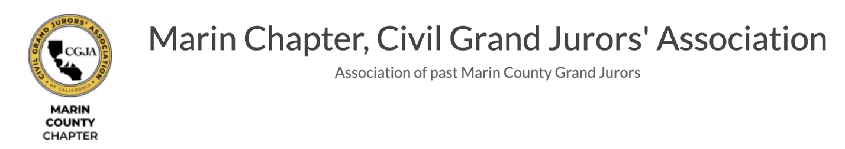

News Bulletin
April 14, 2025 – Vol.3
Civil Grand Jury Releases Report: Safe at School – Let’s Get Educated
SUMMARY: Do Marin County’s children feel safe at school? School climate surveys indicate many students do not.

A highly publicized attack at a Novato middle school last year and a spate of school violence headlines prompted a closer look at how public schools respond to their students; fears, using the Novato Unified School District (NUSD) as a case study.

The Marin County Civil Grand Jury (Grand Jury) focused on the NUSD because of its recent experience addressing a violent attack on a school campus. The NUSD has done extensive work to reinforce and develop policies to address issues plaguing an education system struggling to keep up with twenty-first-century cultural shifts. While the NUSD has made a good start, the Grand Jury is asking the NUSD to do more by extending and maintaining a clearer focus on consistency and training around discipline, using their security resources more effectively, and
improving communication.

The full report can be accessed at:
https://www.marincounty.gov/sites/g/files/fdkgoe241/files/2025-04/feeling-safe-at-school.pdf

Volunteers Needed for 2025-26 Marin Civil Grand Jury Selection Process
The application period for the 2025-26 Marin Civil Grand Jury closes this Tuesday, April 15th, and chapter volunteers are needed to assist with scheduling and interviewing applicants. Interviews will take place at the Marin Civic Center, and those interested in helping can learn more and volunteer by contacting Pat Shepherd at pfshepherd6@gmail.com.

So far, 45 people have applied to serve. All chapter members are asked to encourage promising friends and acquaintances to apply online at: https://www.marincounty.gov/departments/grand-jury

